
• Html
• CSS
• JavaScript
• Tailwind CSS
• Java
• Sql
• MySQL
• React
• Express.Js
• Git and GitHub
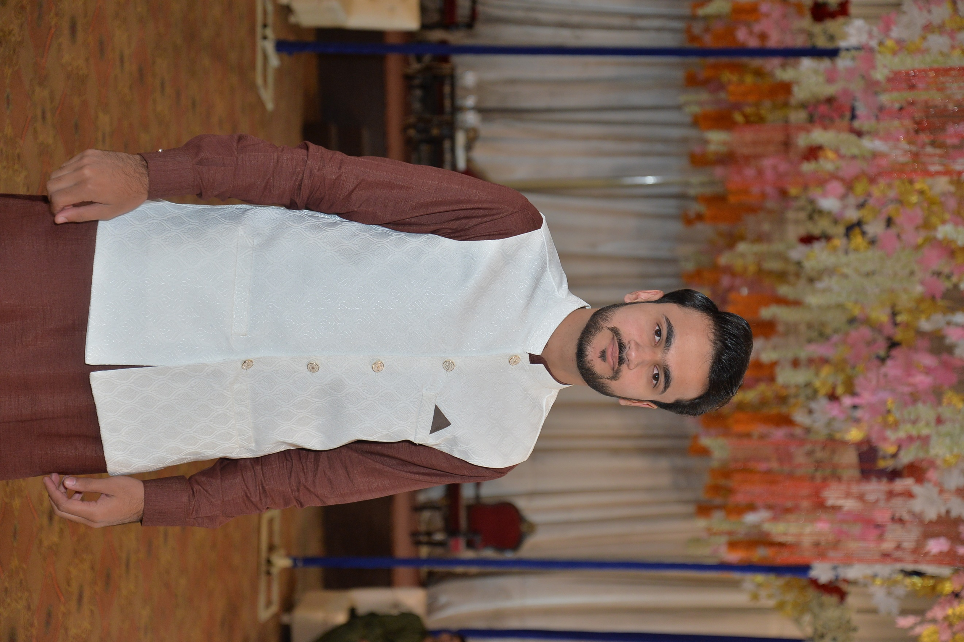 |  | MUhammad Abdullah  Web Development  Front-End And Back-End Developer
Profile  Based in Gujranwala, Pakistan, and presently studying a Bachelor of Science in Data Science in 4th semester, I am an ambitious and self-driven web developer. competent in JavaScript, HTML, and CSS; knowledgeable about a variety of frameworks and libraries, including React and Tailwind CSS. demonstrated aptitude for creating and maintaining web applications' front-end and back-end components through coursework and personal projects. devoted to full stack development and have a strong desire to create scalable, effective, and user-friendly web solutions.  Contact  PHONE:  +923086303187  WEBSITE:  file:///I:/SEMESTER%201/Cs-120/AssiGnment/index.html  EMAIL:  Chaudhayabdullah786@gmail.com  Hobbies  - Front-End Developer  - Back-End Developer  - Full Stack developer  - Android & IOS Application |  | EDUCATION  Matric  Jadeed Dastgir Ideal High School  2017 - To 2019 [Completed]  Marks: 975 out of 1100 Grade: A+  FSc (Pre-medical)  Punjab College  2019 - To 2021[Completed]  Marks: 794 out of 1100 Grade: A  Bachelor in Data Science  Gift University  CGPA 3.10/4.0  2023 - To 2027[In Progress]  WORK EXPERIENCE  Worked on some of the projects in my university. This included use of Html, CSS, JavaScript, Php, Sal. MySQL and Java etc.  • Made some of the projects in React, Tailwind CSS etc., which are all listed on my portfolio website mentioned.  • I have just started learning Backend in NodeJS and Express and I have also worked a little bit on 2 small projects assigned to me by a senior dev to upscale my skill level.  SKILLS

